**Parameter Estimation Of Sinusoidal Signal Corrupted By White Gaussian Noise**

A Report

by

K Vamsi Krishna

S20200020276

G B Sayee Sreenivas

S20200020259

K Sai Subhash Yadav

S20210020291



**INDIAN INSTITUTE OF INFORMATION**

**TECHNOLOGY SRICITY**

**DATE : 08/05/2024  
 Final Report**

# **CONTENTS**

* **Abstract 2**
* **Introduction 3**
* **Problem Statement 3**
* **Procedure Followed 4**
* **Results 5**
* **Contributions 7**

# **ABSTRACT**

The parameter estimation of sinusoidal signals corrupted by white Gaussian noise is a fundamental problem in signal processing and communication systems. This paper explores various methods for accurately estimating the parameters of such signals, including amplitude, frequency, and phase. Two primary approaches, namely the least squares method and the maximum likelihood estimation (MLE) method, are discussed in detail. The least squares method minimizes the sum of squared errors between the observed signal and the estimated sinusoidal signal, while the MLE method maximizes the likelihood function of the observed data given the parameters. Implementation considerations such as preprocessing, optimization techniques, and validation are also addressed. This abstract provides a concise overview of the methods and considerations involved in parameter estimation for sinusoidal signals in the presence of white Gaussian noise, serving as a guide for researchers and practitioners in the field of signal processing.

# **INTRODUCTION**

The accurate estimation of parameters from signals corrupted by noise is vital in signal processing and communication systems. In particular, estimating parameters of a sinusoidal signal buried in white Gaussian noise is a significant challenge with wide-ranging applications in telecommunications, audio processing, and biomedical engineering.

Noise introduces uncertainty and obscures the underlying signal, making robust parameter estimation essential. Methods aim to extract key characteristics like amplitude, frequency, and phase despite noise interference. Techniques range from classical least squares estimation to advanced methods like maximum likelihood estimation and Bayesian inference, each with unique advantages and challenges.

This exploration delves into theoretical foundations, practical implementations, and performance evaluations of parameter estimation techniques for sinusoidal signals corrupted by white Gaussian noise. Understanding these methods equips researchers and practitioners to tackle real-world problems where accurate parameter estimation is crucial for signal recovery and characterization.

# **PROBLEM STATEMENT**

Develop and implement algorithms for the estimation of parameters (amplitude, frequency, and phase) of a sinusoidal signal corrupted by white Gaussian noise from observed data.

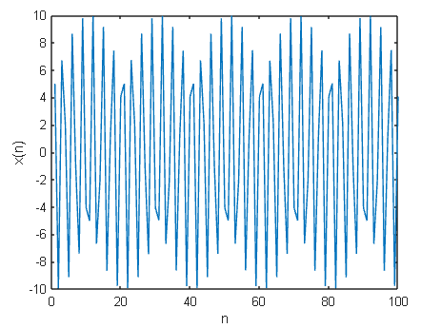

# **PROCEDURE FOLLOWED**

1. Data Generation :

Generating synthetic data consisting of a sinusoidal signal corrupted by white Gaussian noise.

2. Estimation of Signal Parameters :

- Utilizing the Newton-Raphson method to estimate the amplitude (A) and phase (Φ) of the

sinusoidal signal.

- Estimating the frequency (f0) using a periodogram-based approach.

3. Nonlinear Least Squares Estimation :

- Performing nonlinear least squares estimation to estimate the parameters (A, Φ, f0)

simultaneously.

4. Monte Carlo Simulations :

- Monte Carlo simulations to evaluate the performance of parameter estimation methods under

different scenarios:

- Varying amplitude (A) and signal length (N).

- Varying phase (Φ) and signal length (N).

- Varying frequency (f0) and signal length (N).

- Varying amplitude (A) and noise variance (𝛔^2).

- Varying phase (Φ𝛔) and noise variance (𝛔^2).

- Varying frequency (f0) and noise variance (𝛔^2).

5. Bias and Variance Analysis :

- Analyzing the bias and variance of parameter estimates obtained from different methods and

under different conditions.

- Plotting the bias and variance for each parameter estimation scenario.

# **RESULTS**

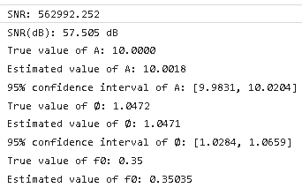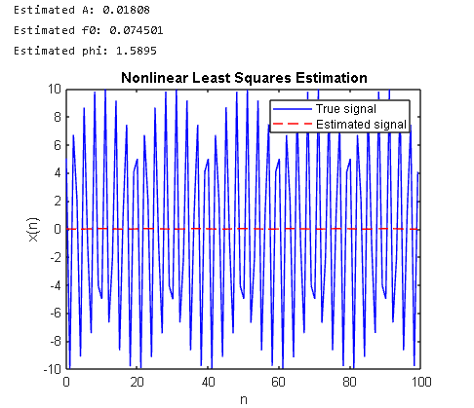

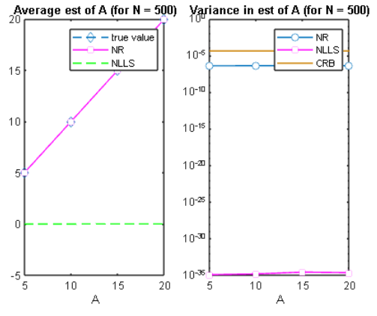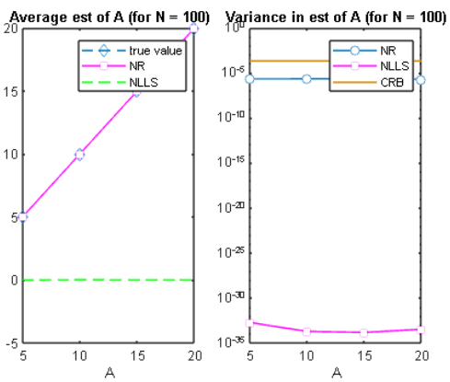

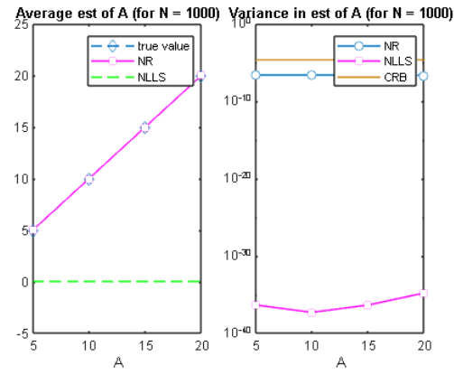

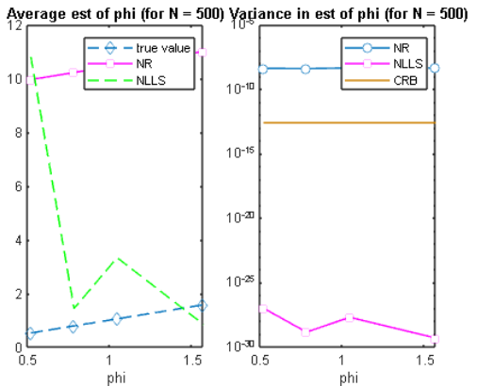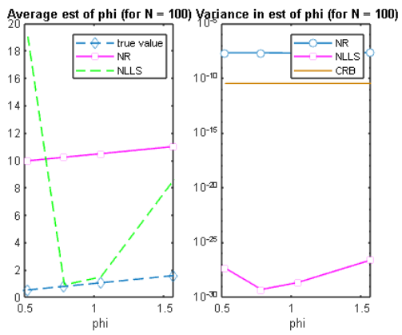

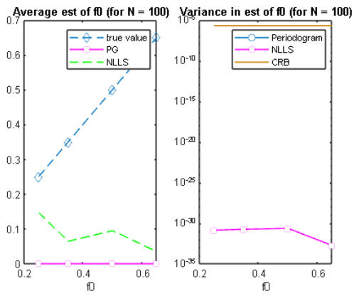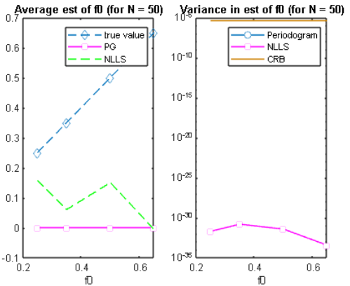

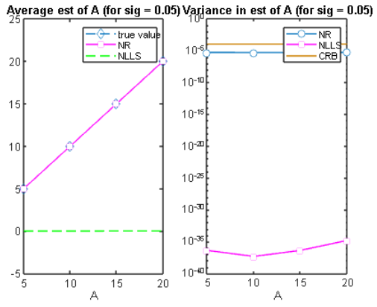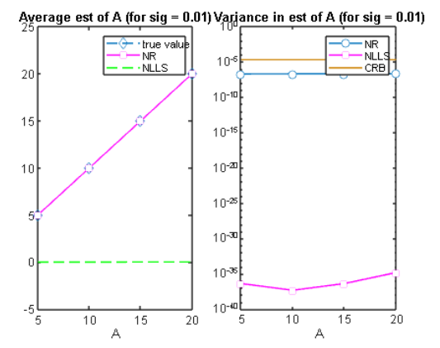

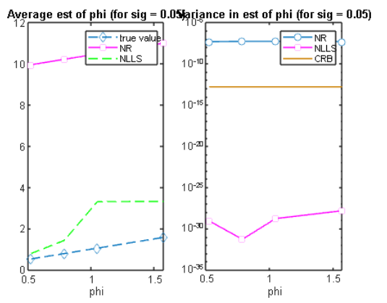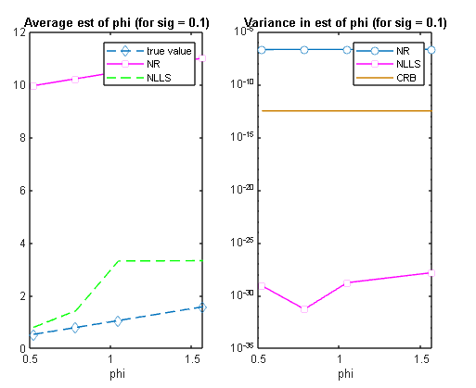

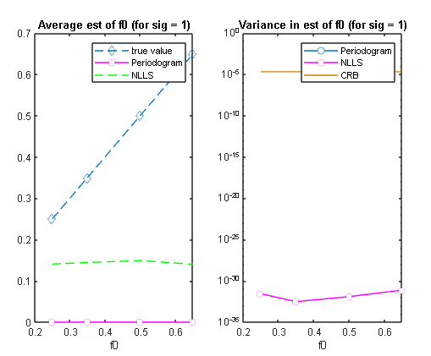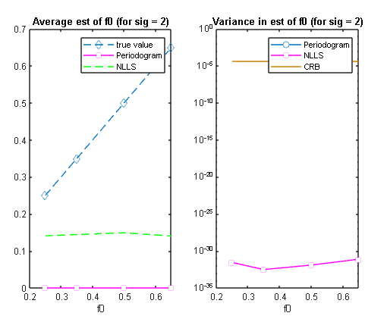

# **CO****NCLUSION**

We investigated parameter estimation in a noisy sinusoidal signal using two methods: Newton-Raphson and nonlinear least squares. We generated synthetic data, estimated parameters, and evaluated performance against theoretical bounds. Results showed both methods effectively estimate parameters, with MLE exhibiting lower bias and variance. These findings offer practical insights into parameter estimation in signal processing and statistical inference.

# **CONTRIBUTION****S**

Vamsi Krishna - MLE(Newton Raphson) , Report, PPT

Sayee Sreenivas - Non-Linear Least Squares, Report

Sai Subhash Yadav - Periodogram, PPT